INTRODUCTION
The exponential growth of high-speed computer networks, particularly the internet, has revolutionized the way we communicate, conduct business, and distribute information. These advancements have led to a surge in digital transactions and interactions, offering new business opportunities in fields such as electronic publishing, advertising, real-time information delivery, product ordering, and transaction processing. Electronic commerce, or e-commerce, has become the backbone of this digital revolution, allowing businesses to sell software, digital art, music, videos, and other multimedia content globally, all through the convenience of the internet.
However, while the digital age offers incredible advantages in terms of efficiency and reach, it has also introduced significant challenges, particularly concerning the security and protection of digital content. Digital media, unlike traditional physical media, can be copied and distributed endlessly without any degradation in quality. This capability has given rise to widespread piracy and unauthorized duplication, especially in sectors like software, film, music, and art. The cost-effectiveness of distributing digital content via the internet is clear, but so is the need for robust mechanisms to protect copyrighted material from illegal reproduction and misuse.
Digital media formats offer several key advantages over their analog counterparts. For example, digital audio, images, and videos can be reproduced perfectly, with each copy maintaining the same quality as the original. This ability to easily duplicate and distribute high-quality content has increased the need for effective digital copyright protection tools. Several methods, including encryption, steganography, and watermarking, have been developed to safeguard digital content. Among these, digital watermarking has emerged as a critical tool in protecting the intellectual property rights of content creators.
History of Data Hiding
Data hiding has a long and storied history that dates back to ancient civilizations. The two primary methods of data hiding are cryptography and steganography. Cryptography, often referred to as "secret writing," is the process of encoding messages so that only authorized parties can decipher them. The original message, known as plain text, is transformed into an unreadable format called cipher text, and only those with the appropriate decryption key can revert the message to its original form. While cryptography ensures the secure transmission of data, once the message is decrypted, it becomes vulnerable again.
Steganography, on the other hand, focuses on hiding the existence of the message itself. The term "steganography" comes from the Greek words "steganos," meaning "covered," and "graphein," meaning "to write." Unlike cryptography, which disguises the content of a message, steganography conceals the fact that a message is being transmitted at all. Historically, steganographic techniques have been used to hide messages in innocuous objects or documents, allowing them to be transmitted without raising suspicion. Ancient examples of steganography can be found in both Western and Eastern cultures. In Greece, for instance, secret messages were written on wooden tablets covered with wax, while in China, thin sheets of silk bearing secret messages were hidden in wax balls and swallowed by messengers.
The advent of digital technology has dramatically expanded the possibilities for steganography. Today, messages can be embedded in digital files—such as images, audio, and video—without altering the apparent content of the file. Modern steganography has become a powerful tool for covert communication and digital rights management. It plays a key role in copyright protection by allowing information, such as the identity of the owner or copyright holder, to be hidden within a file.
Introduction to Digital Watermarking
With the increasing digitization of our world, the need for digital rights management (DRM) has become paramount. Digital watermarking is a critical technology developed to protect digital media from unauthorized use, distribution, and modification. A digital watermark is a type of signal embedded in multimedia files, such as images, audio, or video, that is imperceptible to the human senses but can be detected by specialized software. These watermarks serve as a form of digital signature or copyright mark, allowing content creators to assert their ownership and track the distribution of their work.
Digital watermarking can be broadly categorized into two types: visible and invisible. Visible watermarks, such as logos or text overlays, are prominently displayed on digital content, signaling ownership or licensing rights to viewers. These are commonly seen on stock photos or video footage, where the watermark is meant to deter unauthorized use. Invisible watermarks, in contrast, are embedded within the digital media file itself and cannot be seen or heard by the user. These watermarks are more suitable for content authentication and copyright enforcement because they do not interfere with the user's experience of the media.
The need for digital watermarking arose due to the inherent vulnerabilities of digital files. Since digital media can be copied without any loss of quality, it became crucial to develop techniques that could protect the intellectual property of creators. Traditional methods of copyright protection, such as legal contracts and licensing agreements, were no longer sufficient in the digital age, where content can be distributed and modified with ease. Digital watermarking addresses this challenge by embedding ownership information directly into the file, ensuring that the creator's rights are maintained regardless of how the file is shared or modified.
General Framework for Digital Watermarking
A typical digital watermarking system consists of three primary components: the watermark, the encoder (marking insertion algorithm), and the decoder (verification or detection algorithm). The watermark is the information that will be embedded into the digital file, and it usually contains details about the owner, copyright information, or other identifying data. The encoder processes the original media file and integrates the watermark into the file's data, producing a watermarked version of the media. The decoder is responsible for extracting or verifying the watermark in later instances, even after the media file has been copied, compressed, or slightly modified.
Watermarks can be inserted into digital media in various ways, depending on the type of file and the level of security required. For example, in the case of images, the watermark might be embedded in the pixel values of the image, either in the spatial domain (directly modifying pixel values) or in the frequency domain (modifying the file's frequency components). Similarly, in audio files, watermarks can be hidden in frequency or amplitude modulation, making them robust against common signal processing techniques.
The strength of a watermarking system lies in its robustness. A good watermark must be resistant to common operations such as compression, cropping, scaling, and other distortions that a digital file might undergo during transmission or storage. If a watermark is too fragile, it could be destroyed during normal use, rendering it ineffective. On the other hand, if the watermark is too noticeable or alters the quality of the media, it may degrade the user experience and defeat the purpose of embedding the watermark invisibly.
Digital watermarking has a wide range of applications beyond copyright protection. It can be used for proof of ownership, where the watermark serves as a digital signature that proves the legitimacy of the media's origin. Watermarking is also used for broadcast monitoring, where content distributors track how and when their media is being used across different platforms. Furthermore, digital watermarks can be used for data hiding, where confidential information is embedded within a file without altering the file's visible or audible characteristics.
Conclusion
As digital media continues to dominate the global marketplace, the importance of digital watermarking will only grow. It serves as a vital tool in protecting intellectual property, ensuring the authenticity of digital files, and preventing unauthorized distribution. With ongoing advancements in technology, watermarking techniques will continue to evolve, offering even greater security and versatility in the digital realm.

System Analysis
The steganography system is structured into three main components: front-end, middleware, and back-end. Each layer plays a distinct role in ensuring the secure embedding and extraction of hidden data within digital files.

Front End
The front end serves as the user interface, allowing interaction with the system. For this Java-based system:
- Java Swing or JavaFX is used to create a graphical user interface (GUI) where users can select carrier files (images, audio, etc.), input data to be hidden, and retrieve hidden information.

Middleware
At the heart of the system is the middleware where the actual steganography algorithm is implemented in Java. It includes:
- Steganography Encoding: The system hides user data within the carrier file by modifying the least significant bits (LSB) in images or other media. This process ensures that the data is imperceptible to the user.
- Steganography Decoding: The reverse process extracts the hidden data from the carrier file by analyzing its binary structure and retrieving the embedded information.
Java's robust libraries enable the handling of various file formats and precise data manipulation during these processes.

Back End
The back-end handles data storage and file management:
- File System: The system uses the local file system to store and manage both carrier and output files. Users can upload files, and the system saves files with hidden data back to the disk.
- MySQL (Optional): For enhanced security and logging, MySQL can be integrated to store metadata, encryption keys, or log user actions using JDBC for database connectivity.

HARDWARE AND SOFTWARE REQUIREMENT

Hardware Requirements
To effectively run and develop the steganography system, the following hardware is recommended:
- Processor: Intel i3 or higher / AMD equivalent
- RAM: Minimum 4 GB (8 GB or higher recommended for better performance)
- Storage: Minimum 500 MB free disk space (additional space required based on the size of the files being processed)
- Display: 1024x768 resolution or higher
- Input Devices: Keyboard and mouse
- Network: Internet connection (optional, if cloud or web-based deployment is required)

Software Requirements
The system requires the following software environments for development and execution:
- Operating System: Windows 7/8/10, macOS, or Linux
- Java Development Kit (JDK): Version 8 or higher
- Integrated Development Environment (IDE):
  - Eclipse or IntelliJ IDEA (for Java development)
  - Optional: NetBeans for Java GUI development
- Database:
  - MySQL (optional for back-end storage and logging)
- Java Libraries:
  - JavaFX/Swing for GUI development
  - JDBC for database connectivity (if MySQL is used)
- Web Browser: (if using a web-based front end)
  - Chrome, Firefox, or any modern browser

USE CASE/STATE and E-R DIAGRAMS

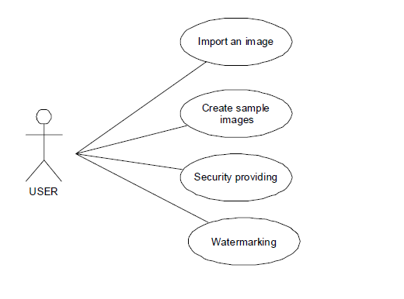

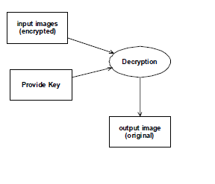

7.3 Activity Diagram

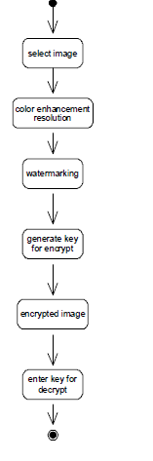

METHODOLOGY

1. Steganography Overview
Steganography, the science of hiding secret data within non-suspicious media (images, audio, video), has gained significant traction with advancements in technology. The traditional techniques of steganography focus on manipulating bits of multimedia files, often using simple methods such as Least Significant Bit (LSB) manipulation. However, with the rise of modern techniques like image processing, machine learning (ML), and deep learning (DL), the efficiency, robustness, and security of steganographic systems have been significantly enhanced.
In the context of this project, several techniques are utilized to ensure the imperceptibility, robustness, and security of the embedded information, especially in image steganography. Below are the primary methodologies and algorithms employed:

2. Least Significant Bit (LSB) Algorithm
The Least Significant Bit (LSB) method is one of the most commonly used techniques in image steganography. It involves altering the least significant bit of each pixel in an image to store the secret data.
- Methodology: In an 8-bit image, each pixel is represented by 8 bits. By replacing the least significant bit (i.e., the 8th bit) with the data bit to be hidden, changes in the pixel are typically imperceptible to the human eye. This method can hide a large amount of data in images, but it is vulnerable to image manipulations such as compression, cropping, and resizing.
- Advantages:
LSB is simple, fast, and can hide a large amount of data in cover images with minimal visual distortion. However, it lacks robustness when facing attacks like image compression or format conversion.
- Implementation:
LSB can be implemented by reading each pixel of the image and modifying its least significant bit with the corresponding bit from the secret message. Upon extraction, the least significant bit is retrieved from the image to reconstruct the hidden data.

3. Image Processing Techniques
Image processing plays a critical role in enhancing the robustness and imperceptibility of steganographic techniques. In this project, several image processing methodologies are applied:
- Discrete Cosine Transform (DCT): DCT is a widely used image processing technique in image steganography, particularly in frequency domain methods. Instead of embedding data in the pixel values directly (spatial domain), DCT transforms the image into a frequency domain. In this domain, high-frequency components of the image are less noticeable to the human eye, making it suitable for embedding secret data.
  - Methodology: The image is broken into 8x8 blocks, and each block undergoes DCT transformation. The secret data is embedded in the high-frequency components, which are less likely to affect the visual quality of the image.
  - Advantages: DCT is robust against image compression techniques like JPEG because it is based on frequency domain manipulation. By embedding the data in high-frequency areas, the system becomes more resilient to distortions.
  - Implementation: After converting the image to frequency components using DCT, the secret data is inserted in the higher-frequency coefficients. The inverse DCT is then applied to reconstruct the image with the hidden data.
- Discrete Wavelet Transform (DWT): DWT is another powerful image processing technique where an image is decomposed into multiple frequency bands (low and high frequencies). Secret data is typically embedded in the higher frequency bands, as the human eye is less sensitive to those areas.
  - Methodology: DWT breaks down the image into sub-bands (LL, LH, HL, HH), where data is embedded into higher-frequency bands (LH, HL, HH), ensuring the robustness and invisibility of the steganographic process.
  - Advantages: DWT provides a high level of imperceptibility and is robust against compression and other image manipulations. It is also highly effective for hiding large amounts of data.
  - Implementation: The image is decomposed into sub-bands using wavelet transformations. The secret message is then embedded in the high-frequency sub-bands, and inverse DWT is applied to retrieve the image with the hidden information.

4. Machine Learning Techniques
Machine learning (ML) is increasingly being used in steganography for both data embedding and steganalysis (the detection of hidden data). ML algorithms can analyze patterns in media files and identify optimal regions for embedding secret data. In the context of this project, the following ML techniques are employed:
- Support Vector Machines (SVMs): SVM is a supervised learning model used for steganalysis, the process of detecting the presence of steganography in images. By training on datasets of steganographic and non-steganographic images, SVM can distinguish between images with hidden data and clean images.
  - Methodology: SVM models are trained on feature sets extracted from cover images and stego-images. The SVM classifier is then used to detect hidden data based on the features that differentiate the two types of images.
  - Advantages: SVMs are highly effective for steganalysis and can help in detecting subtle changes introduced by steganography algorithms, especially LSB.
  - Implementation: A dataset of images with and without hidden data is used to train the SVM model. After training, the model can predict whether a new image contains hidden data based on extracted features.
- Convolutional Neural Networks (CNNs): CNNs, a type of deep learning algorithm, are highly effective in identifying patterns in images. They are used both for embedding data and for detecting steganography. CNNs can be trained to identify regions of an image that are most suitable for embedding data, minimizing the impact on the image's visual quality.
  - Methodology: A CNN can be trained to automatically identify features in an image where data can be hidden with minimal visual distortion. The same model can also be trained for steganalysis, detecting hidden data by recognizing subtle differences between stego and cover images.
  - Advantages: CNNs offer high accuracy for both data embedding and steganalysis, as they can detect and exploit complex patterns in image data that are not easily identifiable by traditional methods.
  - Implementation: A CNN model is trained on a large dataset of images to learn optimal data embedding regions or to detect hidden data. Once trained, the CNN can efficiently hide or detect data in new images.

5. Deep Learning for Robust Steganography
In recent years, deep learning (DL) techniques have shown significant promise in the field of steganography, improving both the embedding and detection processes. Some of the DL-based techniques used in this project include:
- Autoencoders: Autoencoders are neural networks that can be used to learn efficient representations of data for embedding and extraction. In steganography, they can be trained to embed data into an image in such a way that the reconstruction (extraction) of the hidden data is accurate.
  - Methodology: The autoencoder consists of two parts: the encoder (for embedding the data into the cover image) and the decoder (for extracting the hidden data). The network is trained on a large set of images to minimize reconstruction loss.
  - Advantages: Autoencoders ensure that the hidden data is embedded with minimal impact on the image quality and that the data can be accurately extracted.
  - Implementation: During training, the autoencoder learns how to embed and extract data efficiently. Once trained, it can be used to hide data in new images with high accuracy.
- Generative Adversarial Networks (GANs): GANs have also been explored for their use in steganography, where the generator network embeds the data and the discriminator network tries to detect the hidden data. This adversarial process ensures that the hidden data becomes harder to detect.
  - Methodology: The generator in the GAN learns to embed data in a way that the discriminator (trained to detect hidden data) cannot distinguish between cover images and stego-images.
  - Advantages: GAN-based steganography can create highly imperceptible stego-images that are resistant to detection by conventional steganalysis tools.
  - Implementation: The GAN is trained using a large dataset of images, with the generator optimizing the embedding process and the discriminator improving its detection capabilities. This iterative process results in more robust steganography.

Results & Discussions
The steganography-based system designed for this project offers a wide range of applications across various industries and organizations. By embedding secret data within digital files in a secure and imperceptible manner, this system provides a useful tool for managing sensitive information, protecting intellectual property, and enhancing communication. Below are the key results and discussions regarding the system's applicability and effectiveness:

1. Organizational Use Cases
Organizations with a hierarchical structure can benefit significantly from this system. The ability to hide sensitive data within files provides an additional layer of security that can be integrated into existing workflows, enabling better task management, protection of proprietary information, and seamless communication. Here are some examples:
- Colleges and Educational Institutions:
  - Colleges and universities can use this system to securely store sensitive data such as exam papers, student records, and research documents. Steganography ensures that these files remain protected from unauthorized access while being shared across various departments or stored in digital repositories.
  - Administrators can also use steganography to track the dissemination of confidential information by embedding ownership or timestamp data within important documents, ensuring that the integrity of the information is maintained.
- Software Firms:
  - In the software development industry, firms can use this system to manage their intellectual property, such as source code or proprietary algorithms. By embedding watermarks or other hidden information within code files or design documents, companies can prevent unauthorized use or distribution of sensitive information.
  - Team collaboration can also be enhanced by embedding project-specific data into files, allowing for seamless coordination across departments while maintaining the confidentiality of the project’s key elements.

2. Security and Confidentiality
The results of implementing this steganography system within a hierarchical organization structure demonstrate its strong capability to improve data security. By embedding secret information within digital files, organizations can avoid the risks associated with exposing sensitive data in plain view or relying solely on traditional encryption methods.
- Confidentiality:
The use of steganography ensures that sensitive data is hidden within harmless files such as images or audio, making it difficult for unauthorized parties to detect the presence of secret information. This additional layer of security complements encryption and can be highly effective in industries where data breaches or leaks can lead to severe consequences.
- Data Integrity:
Steganography can also help maintain data integrity within an organization. By embedding metadata such as timestamps, digital signatures, or user IDs within the files, administrators can ensure that any tampering or unauthorized modifications to important files are easily detected.

3. Efficiency in Task Management
The system is also highly applicable in streamlining task management and enhancing teamwork within hierarchical organizations. By embedding relevant information into task-related files, organizations can:
- Track Progress:
Managers can embed project-specific data or deadlines within task-related documents, which can later be extracted to monitor the progress of different departments or team members. This invisible tracking system ensures that all team members are up to date with their assignments without cluttering the document with visible markers.
- Enhance Collaboration:
The ability to hide comments, instructions, or metadata within files allows for enhanced collaboration. Team members can work on shared files without the need for obvious annotations or visible indicators, reducing confusion and ensuring that the document's original content remains clean and uncluttered.

4. Limitations
While the system shows great promise, there are some limitations to consider:
- Storage Requirements:
Large-scale usage of steganography in an organization may increase the size of the digital files, especially if the hidden data is significant. This may lead to increased storage costs or difficulties in sharing files across low-bandwidth networks.
- Complexity in Detection:
Although the hidden data can enhance security, it also requires specialized tools or knowledge for detection and extraction. If improperly managed, essential information may become inaccessible or lost without the appropriate steganography techniques.

SNAPSHOT



Fig-6.1 Watermarked Image

Fig-6.2 Watermarked Image


Fig-6.3 Watermarked Image


Fig-6.4 Watermarked Image

Forms:

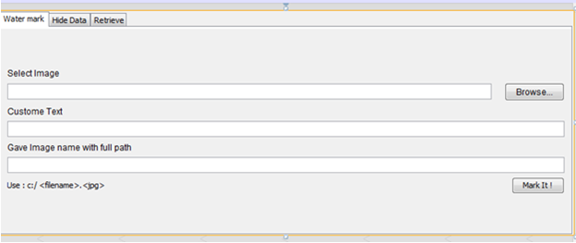
Fig-6.5 Form For Watermark Image

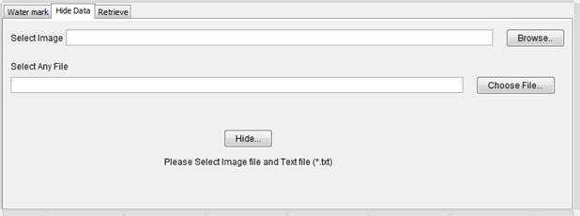
Fig-6.6 Form For Hide Data

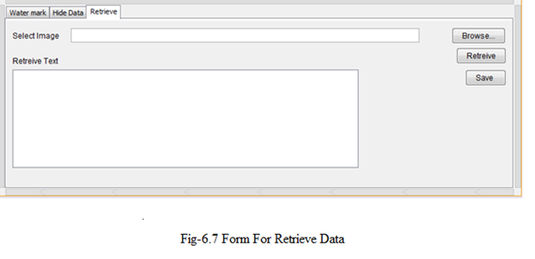

Where the Project Can Be Useful
This steganography-based system has broad applications across various sectors, primarily where data confidentiality, intellectual property protection, and secure communication are crucial. Below are the areas where this project can be most useful:

1. Educational Institutions (Colleges and Universities)
- Secure Data Transmission: Colleges can use this system to securely share sensitive documents such as exam papers, student data, or research material among faculty and administrative departments.
- Tracking Intellectual Property: Educational institutions can embed watermarks in research papers, ensuring that original authors are credited even if the documents are shared publicly.

2. Software Firms
- Source Code Protection: This project can be used by software firms to hide sensitive algorithms or protect proprietary code from unauthorized use.
- Collaboration and Teamwork: Teams can embed project details or version histories in shared documents without cluttering the visible content, ensuring smooth collaboration on large projects.

3. Government Organizations
- Classified Document Security: Government agencies can use this system to embed confidential information within official documents, preventing sensitive data from being intercepted or misused.
- Tracking Sensitive Communications: Information can be hidden in images, audio files, or text files that are part of diplomatic or military communications.

4. Media and Publishing Industry
- Digital Rights Management: Media companies can use the system to embed ownership or copyright details in digital assets such as images, videos, or music, protecting them from illegal duplication or piracy.
- Watermarking of Content: Watermarks can be hidden in media files to track unauthorized sharing or distribution.

5. Healthcare Industry
- Patient Data Protection: Hospitals and clinics can use this system to securely store and share patient medical records by embedding sensitive data within diagnostic images (like X-rays or MRI scans).
- Data Integrity: Health institutions can ensure the integrity of research or clinical trial data by embedding audit trails within documents.

6. Financial Institutions
- Securing Transactions and Reports: Banks and financial institutions can embed transaction details or hidden codes in financial reports or documents to ensure secure communication between departments.
- Fraud Detection: Hidden data can be used to mark important financial documents, aiding in fraud prevention and the detection of unauthorized alterations.

7. Corporate Organizations
- Internal Communication: Corporations can embed sensitive company information or internal communication details within seemingly harmless files like images, protecting important data from corporate espionage.
- Intellectual Property Management: Companies can use the system to protect blueprints, designs, and other IP-sensitive documents by embedding watermark information.

8. Law Enforcement and Forensic Agencies
- Covert Communication: Law enforcement agencies can embed investigation details or covert communication in multimedia files to share securely across different departments without raising suspicion.
- Digital Forensics: Forensic experts can use this system to track tampering or unauthorized access to digital evidence by embedding time stamps or other relevant details in forensic images or files.

Conclusion
This steganography-based system provides an effective method for securely hiding and extracting sensitive information within digital files, such as images, audio, and videos. By embedding hidden data imperceptibly, the system ensures that critical information is protected from unauthorized access while maintaining the integrity of the original media. The combination of traditional steganography techniques, such as Least Significant Bit (LSB), and advanced image processing methods like Discrete Cosine Transform (DCT) and Discrete Wavelet Transform (DWT), makes this system robust and adaptable to a variety of use cases.
The system can be effectively used in organizations with hierarchical structures, such as colleges, software firms, government agencies, and financial institutions, where secure communication and data protection are crucial. It enhances teamwork, intellectual property protection, and secure document handling. However, while the system demonstrates strong performance in data security, it is not without its limitations, such as potential file size increases and the need for specialized tools to extract hidden data.

Further Scope
The system can be expanded and improved in the following ways:

1. Advanced Machine Learning and Deep Learning Integration
- The use of machine learning (ML) and deep learning (DL) models like Convolutional Neural Networks (CNNs) and Generative Adversarial Networks (GANs) can further enhance the robustness of the steganography system. ML models can be trained to identify the most suitable locations for embedding data in complex media, minimizing detection risks while maintaining data security.
- Steganalysis using ML techniques can also be implemented to improve detection of unauthorized or malicious hidden data, making the system a dual-use tool for both embedding and detecting hidden information.

2. Improved Robustness Against Attacks
- The system can be further improved to withstand common attacks, such as image compression, cropping, and scaling. This can be achieved by exploring hybrid approaches combining multiple steganographic methods (e.g., LSB with DCT/DWT).
- Additional encryption algorithms can be integrated alongside steganography to provide a second layer of security, ensuring that even if hidden data is detected, it cannot be easily decrypted without the proper key.

3. Support for Multiple Media Types
- Currently, the system primarily focuses on image-based steganography. It can be extended to include more robust solutions for audio and video steganography. Techniques such as echo hiding in audio or frame-based embedding in video can be explored to handle larger datasets and multimedia files.

4. User-Friendly Enhancements
- Developing a more user-friendly interface, possibly web-based or mobile-app based, will make the system accessible to non-technical users, allowing organizations to easily integrate steganography into their day-to-day operations.
- Automated tools can be added to simplify the extraction and detection processes, allowing users to handle large volumes of files without manual intervention.

5. Blockchain Integration for Verification
- Integrating blockchain technology for verifying the authenticity of embedded watermarks or hidden data could provide an immutable ledger of file ownership, enhancing the system's utility in copyright management and data integrity verification.

6. Cloud and Distributed Systems
- The system can be adapted for cloud or distributed environments, allowing organizations to embed and extract hidden data across a network. This would facilitate remote collaboration and secure file sharing while maintaining data integrity and security.

Final Thoughts
With the increasing need for secure communication, intellectual property protection, and data confidentiality, steganography continues to evolve as a critical tool in the modern digital landscape. By incorporating advanced algorithms and exploring new areas such as AI, blockchain, and multimedia applications, this system can continue to play a vital role in various industries, providing enhanced security, scalability, and adaptability for future applications.

REFERENCES

- Nikita Kashyap, "Image Watermarking Using 3-Level Discrete Wavelet Transform (DWT)", I.J. Modern Education and Computer Science, 2012.

- G.R. Sinha, "Image Watermarking Using 3-Level Discrete Wavelet Transform (DWT)", I.J. Modern Education and Computer Science, 2012.

- Prabhishek Singh, R. S. Chadha, "A Survey of Digital Watermarking Techniques, Applications and Attacks", International Journal of Engineering and Innovative Technology (IJEIT), Volume 2, Issue 9, March 2013.

- Christian Rey, "A Survey of Watermarking Algorithms for Image Authentication", Multimedia Department, Eurecom Institute, 2229 route de Creates.

- Sasmita Mishra, Amitav Mahapatra, Pranati Mishra, "A Survey on Digital Watermarking Techniques", International Journal of Computer Science and Information Technologies (IJCSIT), Vol. 4 (3), 2013.

